# THIRTEENTH SUNDAY IN ORDINARY TIME

## The week ahead

Confessions:

Fr Seba is available to hear confessions.  
Please call the Parish office (020 3105 8577) to book your appointment.

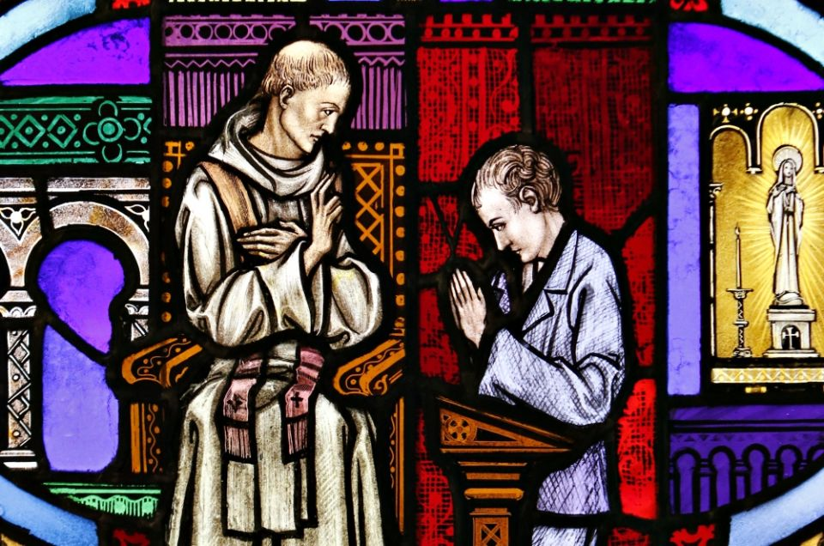

26th & 27th June 2021

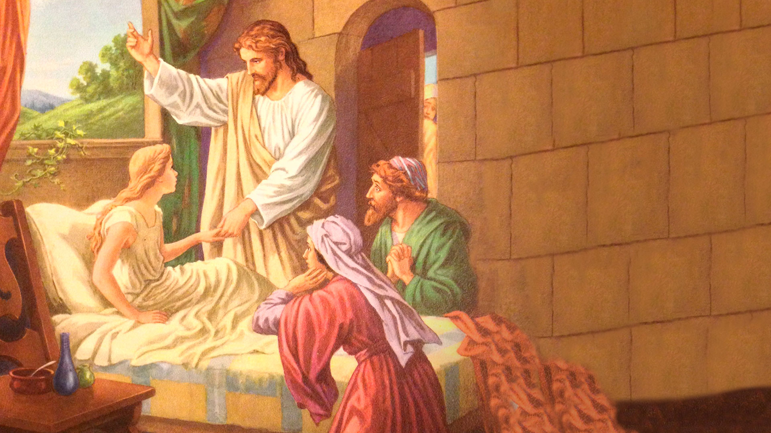

St Joseph’s Church Shooters Hill

|  |  |  |  |  |
| --- | --- | --- | --- | --- |
| Saturday 26th | -- | -- | | |
| Sunday 27th | 10:15am 12 noon | Sunday Mass Sunday Mass | } | 13th Sunday in Ordinary Time |
| Monday 28th | 10am | Mass | | |
| Tuesday 29th | 10am | Feast of St Peter & Paul, Apostles | | |
| Wednesday 30th | 10am | Mass | | |
| Thursday 1st | 10am | Mass | | |
| Friday 2nd | 10am | Mass | | |
| Saturday 3rd | -- | Feast of St Thomas, Apostle | | |
| Sunday 4th | 10:15am 12 noon | Sunday Mass Sunday Mass | } | 14th Sunday in Ordinary Time |

**13th Sunday in Ordinary Time**

In today's Gospel reading, two words," my daughter", is used twice, but in entirely different contexts. In the first instance, the distraught and anxious Jairus begs Jesus to make a house call to heal his beloved twelve-year old child.

Whilst on his way to do this, Jesus encounters someone who should have been completely unacceptable to him – a woman with a medical condition that made her both ritually unclean and socially unacceptable. Jesus refers to this woman as "my daughter", and against the odds, she is fully restored and able to re-join the community.

At the house of Jairus, again, Jesus defeats the odds by restoring life to the little girl, despite the neighbours thinking it was ridiculous even to try.

As followers of Jesus in our time, what do we bring trustfully to him so that we can be made whole again in mind, body, and spirit?

*Bridie Stringer*

Prayer to St Joseph:

Hail, Guardian of the Redeemer, Spouse of the Blessed Virgin Mary. To you God entrusted his only Son;

In you Mary placed her trust; with you Christ became man. Blessed Joseph, to us too, show yourself a father and guide us in the path of life.

Obtain for us grace, mercy and courage, and defend us from every evil. Amen

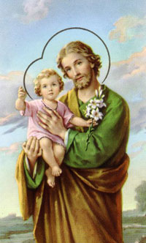

View the Prayer Heroes PowerPoint presentation on our website

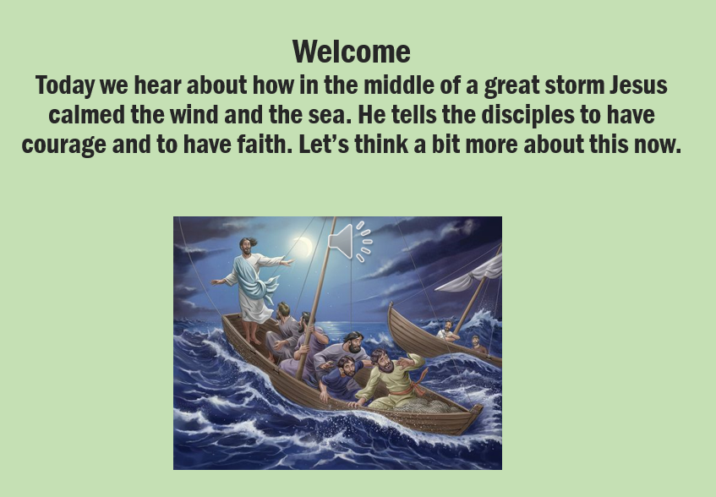

## Notre Dame School News

**Bless our school as we learn together. Nourish our lives with love and joy. Let this be a happy school always, where all are welcomed and respected. A place where we can pray, worship and work together. Amen.**

At Notre Dame primary school, our Prayer Heroes have been working alongside Mrs. Naylor, our RE lead. They have been working hard to create beautiful and relevant PowerPoint presentations to lead Collective Worship sessions, which can be used both in school and at home. The presentations contain prayers, scripture, reflections and often have a follow-on activity. These can be viewed on school website - [www.notredame.greenwich.sch.uk](http://www.notredame.greenwich.sch.uk), under the Catholic Life menu and then Prayer Heroes.

At Notre Dame we believe that we also have a wider responsibility, wider than Notre Dame school and the local community. This week the children joined a CAFOD Zoom session regarding climate change. “Climate change is a problem which can no longer be left to a future generation” stated Pope Francis. The eyes of the world are currently on us this year as Britain hosts world leaders for the UN climate change talks- COP26. CAFOD has been raising the profile of this and encouraging the children to raise their voices, ensuring the government use this historical moment to build a more sustainable world. Children across the school spoke up to make their voices heard. The children have been writing and sending their images to Boris Johnson to let him know that the eyes of the world are watching him.

They took part in the eyes of the world campaign, designing and sharing a picture of their eyes and telling others that they are watching. The artwork produced was particularly powerful and some of these pieces will be shared on the school website.



page 2

THIRTEENTH SUNDAY IN ORDINARY TIME

page 3

THIRTEENTH SUNDAY IN ORDINARY TIME

**Attending mass**

The congregation will be limited to 40 places so please arrive early. Once this capacity has been reached, the door will be closed. Please always wear a mask (unless exempt) and sanitise your hands on entering and leaving church.

**What can I give?**

Our parishes rely heavily on the time, commitment, and dedication of parishioners. They organise our flowers, clean our church, welcome people into the church, prepare the building for our Masses, and facilitate sacramental preparation groups as well as many other responsibilities.

Without these people, we would struggle to function. These jobs may not be for everyone, and many parishioners have family and work pressures to contend with, but everyone can play a part.

Last week we appealed for parishioners to consider putting themselves forward to be part of the parish Finance Committee and the new Parish Pastoral Council. Our current chair of the Finance Committee is stepping down and other members are over-stretched supporting in other ways. It is important that we have a strong finance committee to oversee fundraising and budgeting to help the parish survive financially.

Again, I ask all parishioners who have the skills in this field to reflect on what you can do. The commitment is simply 4 meetings a year lasting around an hour and a half. We would try to have these face to face but we could accommodate members joining remotely if family commitments mean you cannot attend in person.

If you are interested, please speak to me (Fr Seba) either after Mass, call 020 3105 8577 or email [shootershill@rcaos.org.uk](mailto:shootershill@rcaos.org.uk) and we can give you further details.

These are important times for the parish and to survive. If the pandemic has taught us one thing, it is the value of community. This is your time to be an active part in our community.

**London Jesuit Centre vacancies**

The London Jesuit Centre is looking to appoint two members of staff at the centre in Central London.

* Housekeeper (Permanent, 35 hrs/week, £525/week; responsible for leading a team of cleaners/housekeeping staff)
* Receptionist (Permanent, 6 hrs /day, 2pm-8pm, £390/week)

Please see <https://londonjesuitcentre.org/jobs> for more information.

Saint of the day

St Cyril of Alexandria, Bishop & Doctor

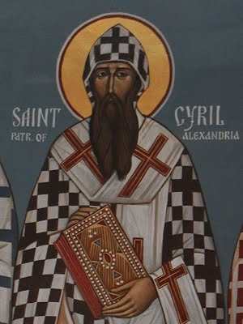

Saint Cyril was the Patriarch of Alexandria, Egypt, from 412-444 A.D, when it was a major city in the late Roman Empire. He was educated, irascible, strong-willed, politically astute, brilliant and utterly convinced that his theology of Christ was correct.

**Liturgical Colour: White**

## Information

page 4

THIRTEENTH SUNDAY IN ORDINARY TIME

**Fundraising for the church**

Esther, one of our parishioners, has kindly signed up to walk and run 10K, to financially support our church. She will need our prayers and donations to achieve this project. Please make donations using the [Donate](https://www.stjoseph-shootershillrcaos.org.uk/) button on the website. Alternatively, you can bring donations in a sealed envelope with *10K walk* written on it and place it in the offertory basket when leaving church.

**Baptism Registration**

If you would like you child to be baptised, here, at St Joseph’s, you will need to complete a Baptism Application Form (you can download the forms from the Sacraments page on our [website](https://92753db5-8ad3-4843-87a4-03faf22f58fb.filesusr.com/ugd/7cf1ff_27647b736ae74853869290814149ed97.pdf) or collect from the back of the church) and attend a Baptism Preparation class. These classes are held on the first Saturday of every month. Please contact Katrina, our Baptism Coordinator, on 07568 502 803 for details and more information.

**Mass Intentions**

If you would like to have a Mass offered for a particular intention, please write your intention down with all the details, together with the Mass stipend, and put it through the Presbytery door. Alternatively, you can contact the parish office on 020 3105 8577 or email [shootershill@rcaos.org.uk](mailto:shootershill@rcaos.org.uk) – Mass intention envelopes are available at both exits of our church.

**Collections**

|  |  |  |
| --- | --- | --- |
| **20th June 2021** | | We are a small parish and are heavily reliant on the kindness and generosity of our parishioners and local community. If you cannot attend mass, please visit our [website](https://www.stjoseph-shootershillrcaos.org.uk/), and click the **Donate** button, or scan the code with your phone, which will take you to our website (all details below). If you are a taxpayer, please remember to tick the *‘Gift Aid’* box. God bless, Ave Maria. |
| **Collection** | **£445** |
| **Candles** | **£265** |
| **Flowers** | **£76** |
| **Total** | **£786** |



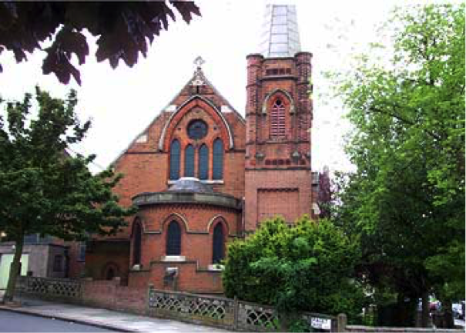

**NOTRE DAME CATHOLIC PRIMARY SCHOOL**

Head Teacher – Mrs. N McNelis

169 Eglinton Road  
London SE18 3SJ

Tel: 020 8 854 0585  
Web: www.notredame.greenwich.sch.uk

### Linked School

**St Joseph’s Catholic Church, Shooters Hill**  
135 Herbert Road  
SE18 3QE

Tel: 0203 105 8577  
Email: shootershill@rcaos.org.uk  
Web: www.stjoseph-shootershillrcaos.org.uk

Diocesan website: www.rcsouthwark.co.uk

## General Information

**HOLY MICHAEL PRAYER**

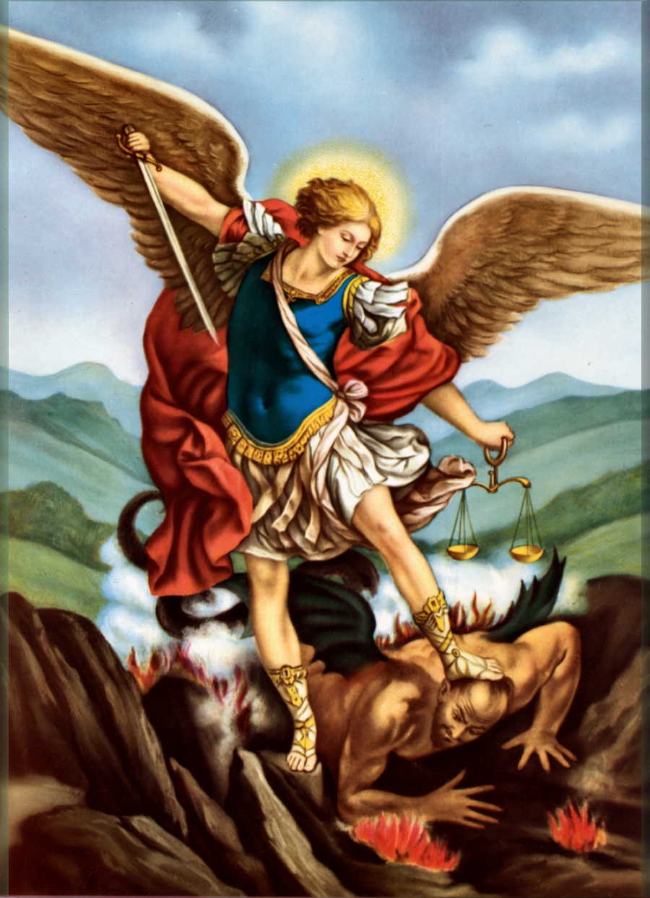

St Michael the Archangel. Defend us in the day of our battle. Be our safeguard against the wickedness and snares of the devil. May God rebuke him, we humbly pray, and do thou, O Prince of Heavenly Hosts, by the power of God, cast into hell satan, and all the evil spirits who wander around the world seeking the ruins of souls.